MODUL PAKET 3
UJI KOMPETENSI KEAHLIAN
REKAYASA PERANGKAT LUNAK
PENGEMBANGAN APLIKASI PENGADUAN SARANA SEKOLAH



SMK AL-IRSYAD KOTA TEGAL
TAHUN AJARAN 2025 / 2026
- Persiapan Software
- XAMPP (jalankan apache dan MySQL)
- Visual Studio Code
- Browser (Chrome / Mozilla)

- Langkah 1 – Membuat Database dan Tabel
- Buka phpMyAdmin di browser = localhost/phpmyadmin
- Buat database baru dengan nama pengaduan_sarana.
- Klik database pengaduan_sarana.
- Klik SQL lalu jalankan query SQL berikut dengan cara menekan tombol Go :

CREATE TABLE admin (
username VARCHAR(50) PRIMARY KEY,
password VARCHAR(255) NOT NULL
);

CREATE TABLE kategori (
id_kategori INT AUTO_INCREMENT PRIMARY KEY,
keterangan_kategori VARCHAR(100) NOT NULL
);

CREATE TABLE siswa (
nis CHAR(10) PRIMARY KEY,
kelas VARCHAR(20) NOT NULL,
password VARCHAR(255) NOT NULL
);

CREATE TABLE aspirasi (
id_aspirasi INT AUTO_INCREMENT PRIMARY KEY,
nis CHAR(10),
id_kategori INT,
lokasi VARCHAR(100),
keterangan TEXT,
foto VARCHAR(255),
status ENUM('menunggu', 'proses', 'selesai') DEFAULT 'menunggu',
feedback TEXT,
tanggal_pelaporan TIMESTAMP DEFAULT CURRENT_TIMESTAMP,
FOREIGN KEY (nis) REFERENCES siswa(nis),
FOREIGN KEY (id_kategori) REFERENCES kategori(id_kategori)
);

INSERT INTO admin VALUES ('admin', 'admin123');

INSERT INTO kategori (keterangan_kategori) VALUES ('Bangunan'), ('Kebersihan'), ('Elektronik'), ('Mebel');

INSERT INTO siswa VALUES ('12345', 'XII RPL 1', 'siswa123');

- Langkah 2 – Struktur Folder Proyek
Buatlah folder di dalam htdocs [LocalDisk C:\xampp\htdocs\] dengan nama pengaduan_sarana
Kemudian isi folder tersebut dengan struktur sebagai berikut :
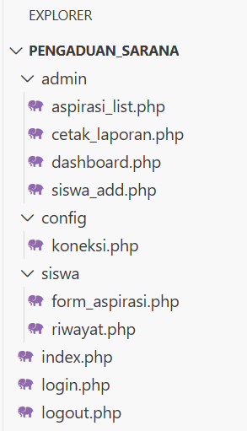
- Langkah 3 – Koneksi Database (config/koneksi.php)
File ini sangat krusial sebagai penghubung antara PHP dan MySQL.
Buka file koneksi.php yang ada pada folder config, kemudian isi dengan kode berikut :
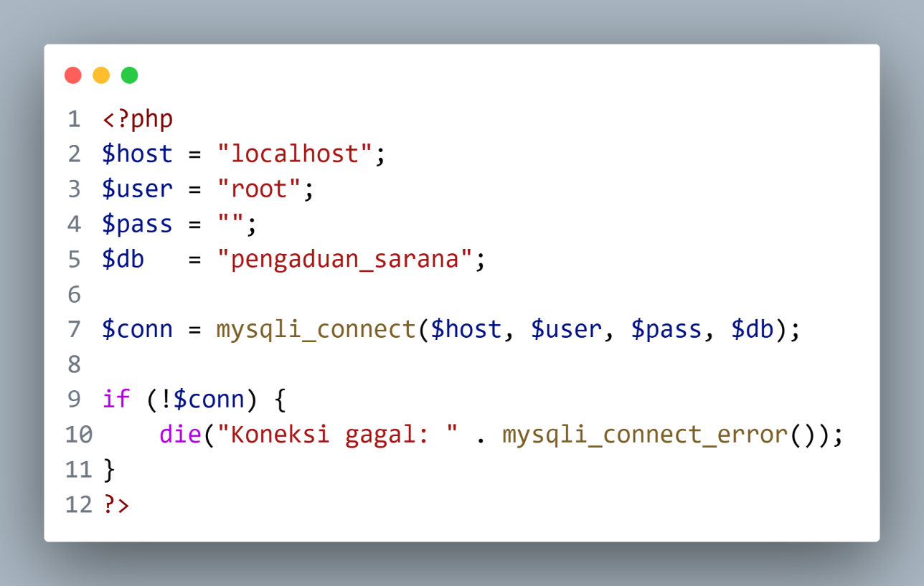
<?php
$host = "localhost";
$user = "root";
$pass = "";
$db = "pengaduan_sarana";

$conn = mysqli_connect($host, $user, $pass, $db);

if (!$conn) {
die("Koneksi gagal: " . mysqli_connect_error());
}
?>

- Langkah 4 – Halaman Login Multilevel (login.php)
Halaman ini akan mendeteksi apakah yang masuk adalah Admin (berdasarkan username) atau Siswa (berdasarkan NIS).
Buka file login.php yang ada pada folder utama pengaduan_sarana, kemudian isi dengan kode berikut :
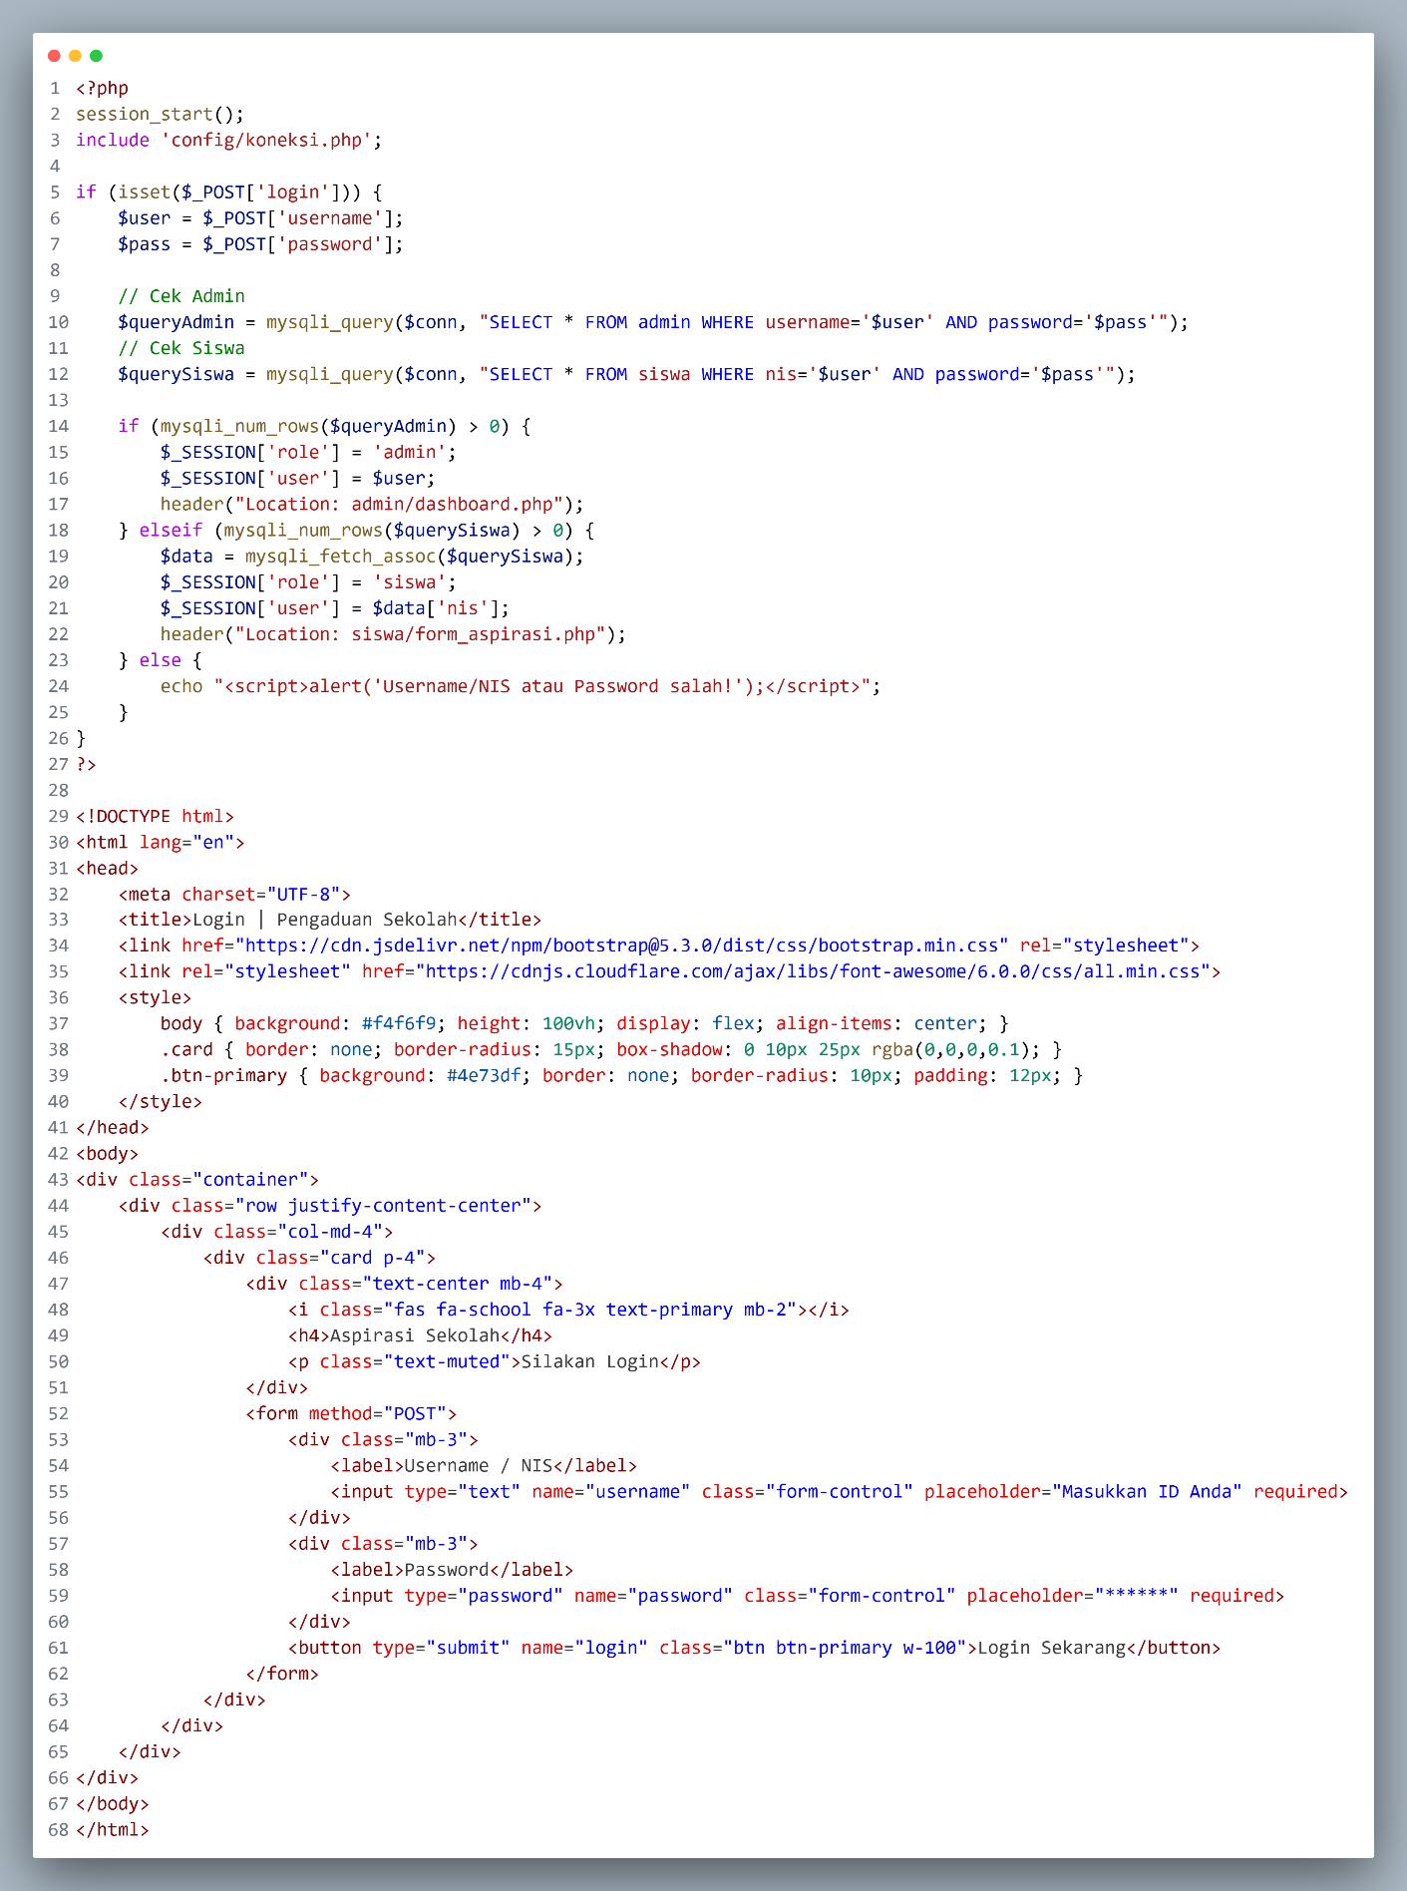
<?php
session_start();
include 'config/koneksi.php';

if (isset($_POST['login'])) {
$user = $_POST['username'];
$pass = $_POST['password'];

// Cek Admin
$queryAdmin = mysqli_query($conn, "SELECT * FROM admin WHERE username='$user' AND password='$pass'");
// Cek Siswa
$querySiswa = mysqli_query($conn, "SELECT * FROM siswa WHERE nis='$user' AND password='$pass'");

if (mysqli_num_rows($queryAdmin) > 0) {
$_SESSION['role'] = 'admin';
$_SESSION['user'] = $user;
header("Location: admin/dashboard.php");
} elseif (mysqli_num_rows($querySiswa) > 0) {
$data = mysqli_fetch_assoc($querySiswa);
$_SESSION['role'] = 'siswa';
$_SESSION['user'] = $data['nis'];
header("Location: siswa/form_aspirasi.php");
} else {
echo "<script>alert('Username/NIS atau Password salah!');</script>";
}
}
?>

<!DOCTYPE html>
<html lang="en">
<head>
<meta charset="UTF-8">
<title>Login | Pengaduan Sekolah</title>
<link href="https://cdn.jsdelivr.net/npm/bootstrap@5.3.0/dist/css/bootstrap.min.css" rel="stylesheet">
<link rel="stylesheet" href="https://cdnjs.cloudflare.com/ajax/libs/font-awesome/6.0.0/css/all.min.css">
<style>
body { background: #f4f6f9; height: 100vh; display: flex; align-items: center; }
.card { border: none; border-radius: 15px; box-shadow: 0 10px 25px rgba(0,0,0,0.1); }
.btn-primary { background: #4e73df; border: none; border-radius: 10px; padding: 12px; }
</style>
</head>
<body>
<div class="container">
<div class="row justify-content-center">
<div class="col-md-4">
<div class="card p-4">
<div class="text-center mb-4">
<i class="fas fa-school fa-3x text-primary mb-2"></i>
<h4>E-Pengaduan Sekolah</h4>
<p class="text-muted">Silakan Login</p>
</div>
<form method="POST">
<div class="mb-3">
<label>Username / NIS</label>
<input type="text" name="username" class="form-control" placeholder="Masukkan ID Anda" required>
</div>
<div class="mb-3">
<label>Password</label>
<input type="password" name="password" class="form-control" placeholder="******" required>
</div>
<button type="submit" name="login" class="btn btn-primary w-100">Login Sekarang</button>
</form>
</div>
</div>
</div>
</div>
</body>
</html>

- Langkah 5 – Halaman Form Aspirasi Siswa (siswa/form_aspirasi.php)
Halaman ini didesain agar siswa mudah menginput keluhan. Kita menggunakan Bootstrap Card untuk membungkus formnya.
Buka file form_aspirasi.php yang ada pada folder siswa, kemudian isi dengan kode berikut :
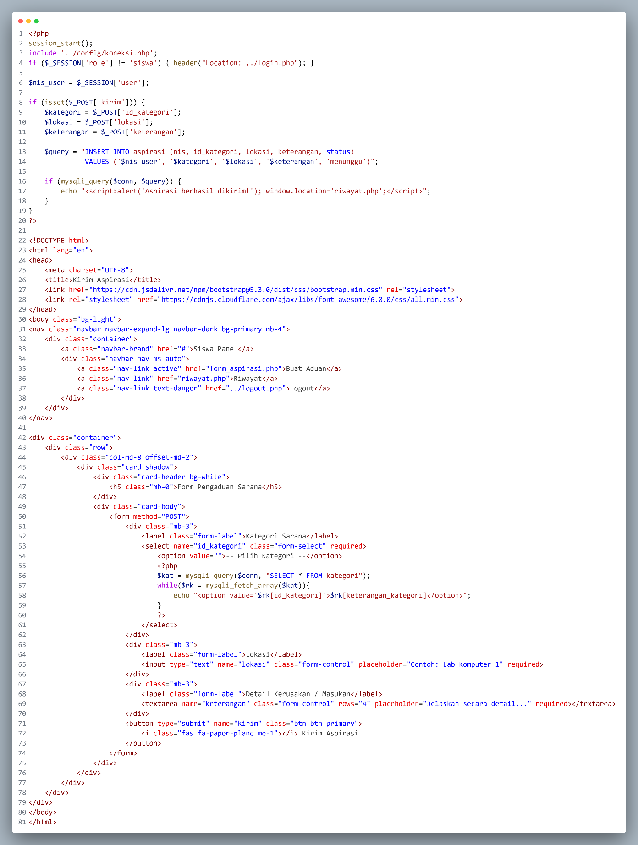
<?php
session_start();
include '../config/koneksi.php';
if ($_SESSION['role'] != 'siswa') { header("Location: ../login.php"); }

$nis_user = $_SESSION['user'];

if (isset($_POST['kirim'])) {
$kategori = $_POST['id_kategori'];
$lokasi = $_POST['lokasi'];
$keterangan = $_POST['keterangan'];

$query = "INSERT INTO aspirasi (nis, id_kategori, lokasi, keterangan, status) VALUES ('$nis_user', '$kategori', '$lokasi', '$keterangan', 'menunggu')";

if (mysqli_query($conn, $query)) {
echo "<script>alert('Aspirasi berhasil dikirim!'); window.location='riwayat.php';</script>";
}
}
?>

<!DOCTYPE html>
<html lang="en">
<head>
<meta charset="UTF-8">
<title>Kirim Aspirasi</title>
<link href="https://cdn.jsdelivr.net/npm/bootstrap@5.3.0/dist/css/bootstrap.min.css" rel="stylesheet">
<link rel="stylesheet" href="https://cdnjs.cloudflare.com/ajax/libs/font-awesome/6.0.0/css/all.min.css">
</head>
<body class="bg-light">
<nav class="navbar navbar-expand-lg navbar-dark bg-primary mb-4">
<div class="container">
<a class="navbar-brand" href="#">Siswa Panel</a>
<div class="navbar-nav ms-auto">
<a class="nav-link active" href="form_aspirasi.php">Buat Aduan</a>
<a class="nav-link" href="riwayat.php">Riwayat</a>
<a class="nav-link text-danger" href="../logout.php">Logout</a>
</div>
</div>
</nav>

<div class="container">
<div class="row">
<div class="col-md-8 offset-md-2">
<div class="card shadow">
<div class="card-header bg-white">
<h5 class="mb-0">Form Pengaduan Sarana</h5>
</div>
<div class="card-body">
<form method="POST">
<div class="mb-3">
<label class="form-label">Kategori Sarana</label>
<select name="id_kategori" class="form-select" required>
<option value="">-- Pilih Kategori --</option>
<?php
$kat = mysqli_query($conn, "SELECT * FROM kategori");
while($rk = mysqli_fetch_array($kat)){
echo "<option value='$rk[id_kategori]'>$rk[keterangan_kategori]</option>";
}
?>
</select>
</div>
<div class="mb-3">
<label class="form-label">Lokasi</label>
<input type="text" name="lokasi" class="form-control" placeholder="Contoh: Lab Komputer 1" required>
</div>
<div class="mb-3">
<label class="form-label">Detail Kerusakan / Masukan</label>
<textarea name="keterangan" class="form-control" rows="4" placeholder="Jelaskan secara detail..." required></textarea>
</div>
<button type="submit" name="kirim" class="btn btn-primary">
<i class="fas fa-paper-plane me-1"></i> Kirim Aspirasi
</button>
</form>
</div>
</div>
</div>
</div>
</div>
</body>
</html>

- Langkah 6 – File Logout (logout.php)
Sederhana tapi penting untuk keamanan.
Buka file logout.php yang ada pada folder utama pengaduan_sarana, kemudian isi dengan kode berikut :
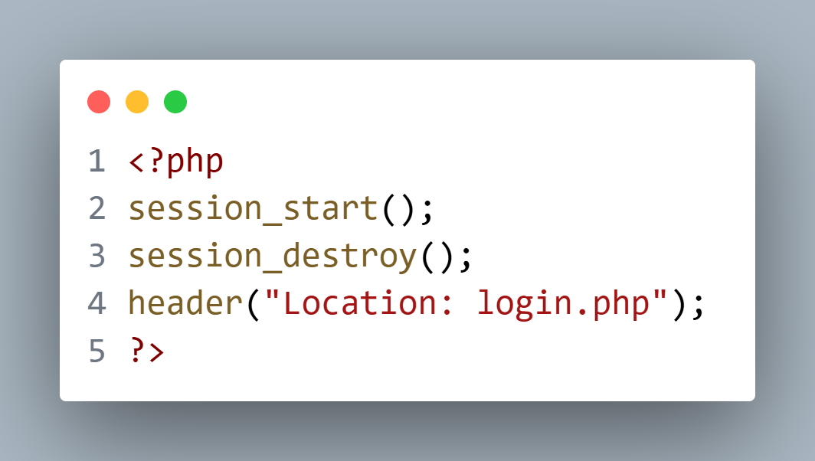
<?php
session_start();
session_destroy();
header("Location: login.php");
?>

- Langkah 7 – Halaman Riwayat Aspirasi Siswa (siswa/riwayat.php)
Halaman ini menampilkan tabel status penyelesaian, progres, dan umpan balik dari admin secara transparan.
Buka file riwayat.php yang ada pada folder siswa, kemudian isi dengan kode berikut :
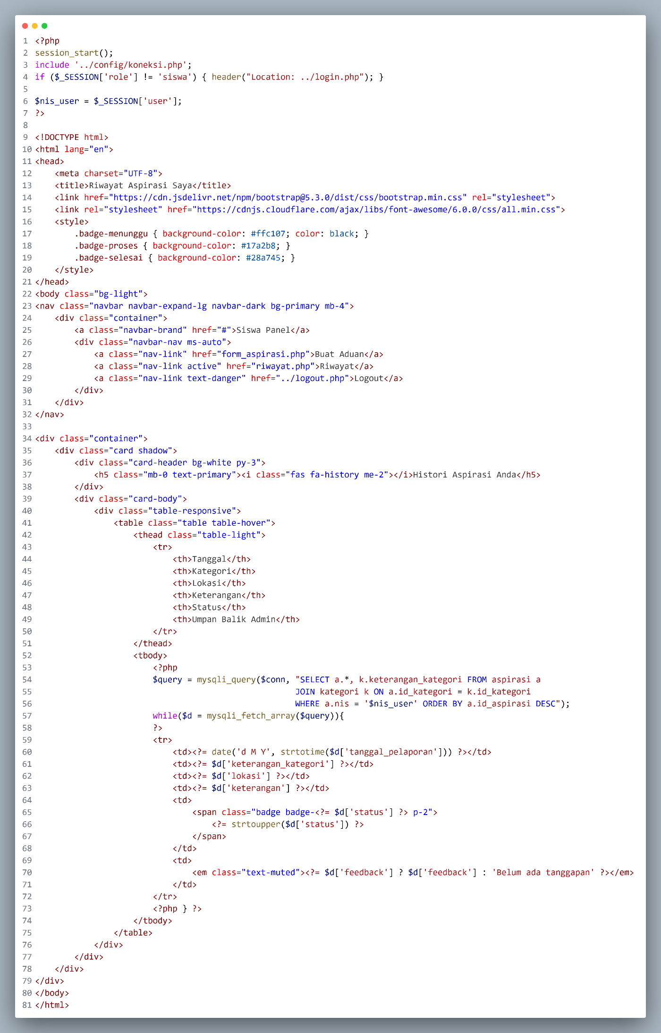
<?php
session_start();
include '../config/koneksi.php';
if ($_SESSION['role'] != 'siswa') { header("Location: ../login.php"); }

$nis_user = $_SESSION['user'];
?>

<!DOCTYPE html>
<html lang="en">
<head>
<meta charset="UTF-8">
<title>Riwayat Aspirasi Saya</title>
<link href="https://cdn.jsdelivr.net/npm/bootstrap@5.3.0/dist/css/bootstrap.min.css" rel="stylesheet">
<link rel="stylesheet" href="https://cdnjs.cloudflare.com/ajax/libs/font-awesome/6.0.0/css/all.min.css">
<style>
.badge-menunggu { background-color: #ffc107; color: black; }
.badge-proses { background-color: #17a2b8; }
.badge-selesai { background-color: #28a745; }
</style>
</head>
<body class="bg-light">
<nav class="navbar navbar-expand-lg navbar-dark bg-primary mb-4">
<div class="container">
<a class="navbar-brand" href="#">Siswa Panel</a>
<div class="navbar-nav ms-auto">
<a class="nav-link" href="form_aspirasi.php">Buat Aduan</a>
<a class="nav-link active" href="riwayat.php">Riwayat</a>
<a class="nav-link text-danger" href="../logout.php">Logout</a>
</div>
</div>
</nav>

<div class="container">
<div class="card shadow">
<div class="card-header bg-white py-3">
<h5 class="mb-0 text-primary"><i class="fas fa-history me-2"></i>Histori Aspirasi Anda</h5>
</div>
<div class="card-body">
<div class="table-responsive">
<table class="table table-hover">
<thead class="table-light">
<tr>
<th>Tanggal</th>
<th>Kategori</th>
<th>Lokasi</th>
<th>Keterangan</th>
<th>Status</th>
<th>Umpan Balik Admin</th>
</tr>
</thead>
<tbody>
<?php
$query = mysqli_query($conn, "SELECT a.*, k.keterangan_kategori FROM aspirasi a
JOIN kategori k ON a.id_kategori = k.id_kategori
WHERE a.nis = '$nis_user' ORDER BY a.id_aspirasi DESC");
while($d = mysqli_fetch_array($query)){
?>

<tr>
<td><?= date('d M Y', strtotime($d['tanggal_pelaporan'])) ?></td>
<td><?= $d['keterangan_kategori'] ?></td>
<td><?= $d['lokasi'] ?></td>
<td><?= $d['keterangan'] ?></td>
<td><span class="badge badge-<?= $d['status'] ?> p-2">
<?= strtoupper($d['status']) ?></span></td>
<td><em class="text-muted"><?= $d['feedback'] ? $d['feedback'] : 'Belum ada tanggapan' ?></em></td>
</tr>
<?php } ?>
</tbody>
</table>
</div>
</div>
</div>
</div>
</body>
</html>

- Langkah 8 – Dashboard Admin (admin/dashboard.php)
Kita akan menggunakan template AdminLTE 3 (via CDN) untuk memudahkan kalian agar tidak perlu download assets
Dashboard ini akan menampilkan statistik jumlah laporan.
Buka file dashboard.php yang ada pada folder admin, kemudian isi dengan kode berikut :
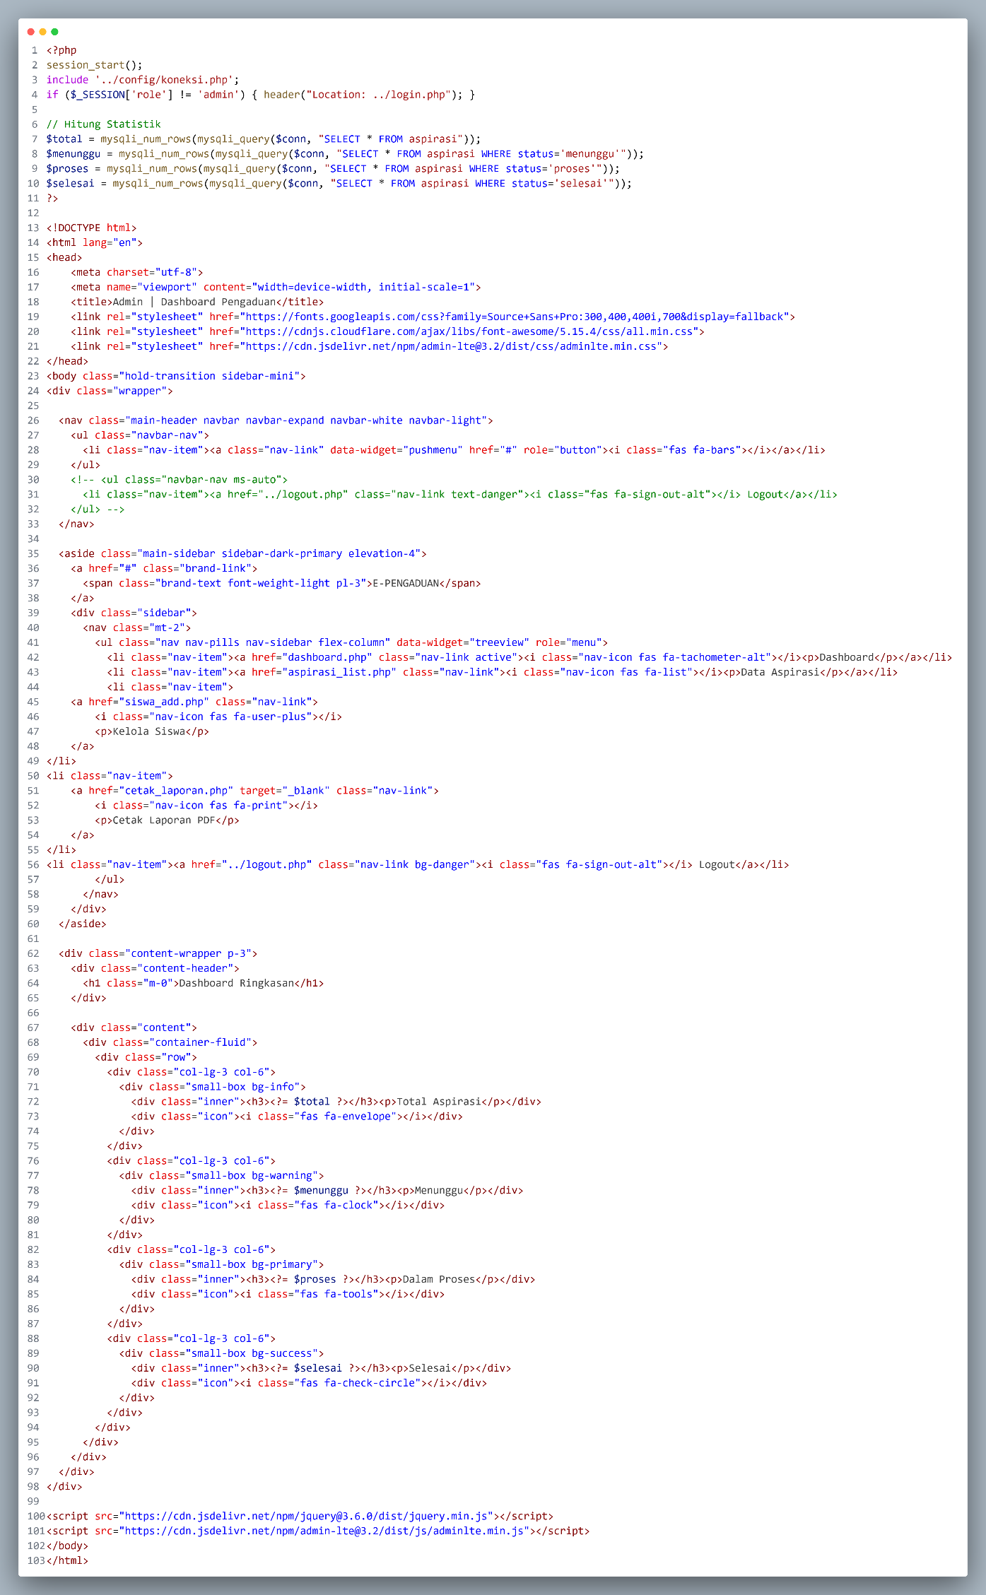
<?php
session_start();
include '../config/koneksi.php';
if ($_SESSION['role'] != 'admin') { header("Location: ../login.php"); }

// Hitung Statistik
$total = mysqli_num_rows(mysqli_query($conn, "SELECT * FROM aspirasi"));
$menunggu = mysqli_num_rows(mysqli_query($conn, "SELECT * FROM aspirasi WHERE status='menunggu'"));
$proses = mysqli_num_rows(mysqli_query($conn, "SELECT * FROM aspirasi WHERE status='proses'"));
$selesai = mysqli_num_rows(mysqli_query($conn, "SELECT * FROM aspirasi WHERE status='selesai'"));
?>

<!DOCTYPE html>
<html lang="en">
<head>
<meta charset="utf-8">
<meta name="viewport" content="width=device-width, initial-scale=1">
<title>Admin | Dashboard Pengaduan</title>
<link rel="stylesheet" href="https://fonts.googleapis.com/css?family=Source+Sans+Pro:300,400,400i,700&display=fallback">
<link rel="stylesheet" href="https://cdnjs.cloudflare.com/ajax/libs/font-awesome/5.15.4/css/all.min.css">
<link rel="stylesheet" href="https://cdn.jsdelivr.net/npm/admin-lte@3.2/dist/css/adminlte.min.css">
</head>
<body class="hold-transition sidebar-mini">
<div class="wrapper">

<nav class="main-header navbar navbar-expand navbar-white navbar-light">
<ul class="navbar-nav">
<li class="nav-item"><a class="nav-link" data-widget="pushmenu" href="#" role="button"><i class="fas fa-bars"></i></a></li>
</ul>
</nav>

<aside class="main-sidebar sidebar-dark-primary elevation-4">
<a href="#" class="brand-link">
<span class="brand-text font-weight-light pl-3">E-PENGADUAN</span>
</a>
<div class="sidebar">
<nav class="mt-2">
<ul class="nav nav-pills nav-sidebar flex-column" data-widget="treeview" role="menu">
<li class="nav-item"><a href="dashboard.php" class="nav-link active"><i class="nav-icon fas fa-tachometer-alt"></i><p>Dashboard</p></a></li>
<li class="nav-item"><a href="aspirasi_list.php" class="nav-link"><i class="nav-icon fas fa-list"></i><p>Data Aspirasi</p></a></li>
<li class="nav-item">
<a href="siswa_add.php" class="nav-link">
<i class="nav-icon fas fa-user-plus"></i>
<p>Kelola Siswa</p>
</a>
</li>
<li class="nav-item">
<a href="cetak_laporan.php" target="_blank" class="nav-link">
<i class="nav-icon fas fa-print"></i>
<p>Cetak Laporan PDF</p>
</a>
</li>
<li class="nav-item"><a href="../logout.php" class="nav-link bg-danger"><i class="fas fa-sign-out-alt"></i> Logout</a></li>
</ul>
</nav>
</div>
</aside>

<div class="content-wrapper p-3">
<div class="content-header">
<h1 class="m-0">Dashboard Ringkasan</h1>
</div>

<div class="content">
<div class="container-fluid">
<div class="row">
<div class="col-lg-3 col-6">
<div class="small-box bg-info">
<div class="inner"><h3><?= $total ?></h3><p>Total Aspirasi</p></div>
<div class="icon"><i class="fas fa-envelope"></i></div>
</div>
</div>
<div class="col-lg-3 col-6">
<div class="small-box bg-warning">
<div class="inner"><h3><?= $menunggu ?></h3><p>Menunggu</p></div>
<div class="icon"><i class="fas fa-clock"></i></div>
</div>
</div>
<div class="col-lg-3 col-6">
<div class="small-box bg-primary">
<div class="inner"><h3><?= $proses ?></h3><p>Dalam Proses</p></div>
<div class="icon"><i class="fas fa-tools"></i></div>
</div>
</div>
<div class="col-lg-3 col-6">
<div class="small-box bg-success">
<div class="inner"><h3><?= $selesai ?></h3><p>Selesai</p></div>
<div class="icon"><i class="fas fa-check-circle"></i></div>
</div>
</div>
</div>
</div>
</div>
</div>
</div>

<script src="https://cdn.jsdelivr.net/npm/jquery@3.6.0/dist/jquery.min.js"></script>
<script src="https://cdn.jsdelivr.net/npm/admin-lte@3.2/dist/js/adminlte.min.js"></script>
</body>
</html>

- Langkah 9 – Halaman Daftar Aspirasi Admin (admin/aspirasi_list.php)
File ini akan menampilkan semua data secara detail dan memiliki tombol aksi untuk mengubah status serta memberikan feedback.
Buka file aspirasi_list.php yang ada pada folder admin, kemudian isi dengan kode berikut :
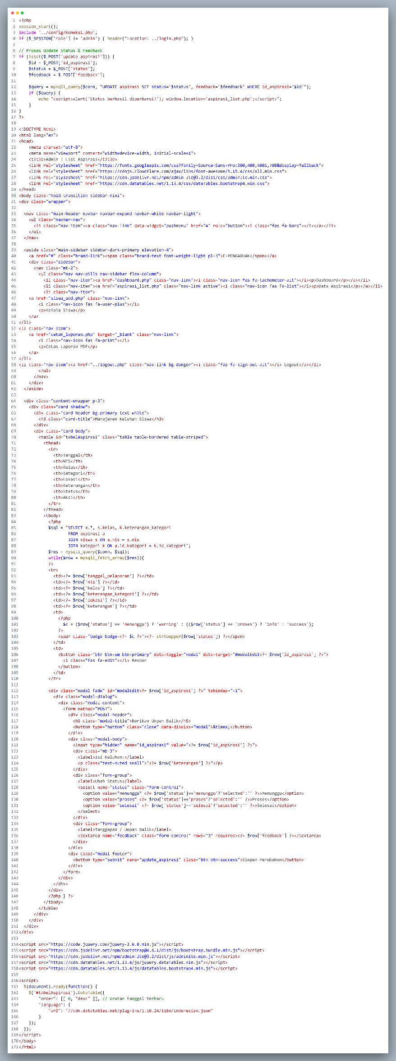
<?php
session_start();
include '../config/koneksi.php';
if ($_SESSION['role'] != 'admin') { header("Location: ../login.php"); }

// Proses Update Status & Feedback
if (isset($_POST['update_aspirasi'])) {
$id = $_POST['id_aspirasi'];
$status = $_POST['status'];
$feedback = $_POST['feedback'];

$query = mysqli_query($conn, "UPDATE aspirasi SET status='$status', feedback='$feedback' WHERE id_aspirasi='$id'");
if ($query) {
echo "<script>alert('Status berhasil diperbarui!'); window.location='aspirasi_list.php';</script>";
}
}
?>

<!DOCTYPE html>
<html lang="en">
<head>
<meta charset="utf-8">
<meta name="viewport" content="width=device-width, initial-scale=1">
<title>Admin | List Aspirasi</title>
<link rel="stylesheet" href="https://fonts.googleapis.com/css?family=Source+Sans+Pro:300,400,400i,700&display=fallback">
<link rel="stylesheet" href="https://cdnjs.cloudflare.com/ajax/libs/font-awesome/5.15.4/css/all.min.css">
<link rel="stylesheet" href="https://cdn.jsdelivr.net/npm/admin-lte@3.2/dist/css/adminlte.min.css">
<link rel="stylesheet" href="https://cdn.datatables.net/1.13.4/css/dataTables.bootstrap4.min.css">
</head>
<body class="hold-transition sidebar-mini">
<div class="wrapper">

<nav class="main-header navbar navbar-expand navbar-white navbar-light">
<ul class="navbar-nav">
<li class="nav-item"><a class="nav-link" data-widget="pushmenu" href="#" role="button"><i class="fas fa-bars"></i></a></li>
</ul>
</nav>

<aside class="main-sidebar sidebar-dark-primary elevation-4">
<a href="#" class="brand-link"><span class="brand-text font-weight-light pl-3">E-PENGADUAN</span></a>
<div class="sidebar">
<nav class="mt-2">
<ul class="nav nav-pills nav-sidebar flex-column">
<li class="nav-item"><a href="dashboard.php" class="nav-link"><i class="nav-icon fas fa-tachometer-alt"></i><p>Dashboard</p></a></li>
<li class="nav-item"><a href="aspirasi_list.php" class="nav-link active"><i class="nav-icon fas fa-list"></i><p>Data Aspirasi</p></a></li>
<li class="nav-item">
<a href="siswa_add.php" class="nav-link">
<i class="nav-icon fas fa-user-plus"></i>
<p>Kelola Siswa</p>
</a>
</li>
<li class="nav-item">
<a href="cetak_laporan.php" target="_blank" class="nav-link">
<i class="nav-icon fas fa-print"></i>
<p>Cetak Laporan PDF</p>
</a>
</li>
<li class="nav-item"><a href="../logout.php" class="nav-link bg-danger"><i class="fas fa-sign-out-alt"></i> Logout</a></li>
</ul>
</nav>
</div>
</aside>

<div class="content-wrapper p-3">
<div class="card shadow">
<div class="card-header bg-primary text-white">
<h3 class="card-title">Manajemen Keluhan Siswa</h3>
</div>
<div class="card-body">
<table id="tabelAspirasi" class="table table-bordered table-striped">
<thead>
<tr>
<th>Tanggal</th>
<th>NIS</th>
<th>Kelas</th>
<th>Kategori</th>
<th>Lokasi</th>
<th>Keterangan</th>
<th>Status</th>
<th>Aksi</th>
</tr>
</thead>
<tbody>
<?php
$sql = "SELECT a.*, s.kelas, k.keterangan_kategori
FROM aspirasi a
JOIN siswa s ON a.nis = s.nis
JOIN kategori k ON a.id_kategori = k.id_kategori";
$res = mysqli_query($conn, $sql);
while($row = mysqli_fetch_array($res)){
?>
<tr>
<td><?= $row['tanggal_pelaporan'] ?></td>
<td><?= $row['nis'] ?></td>
<td><?= $row['kelas'] ?></td>
<td><?= $row['keterangan_kategori'] ?></td>
<td><?= $row['lokasi'] ?></td>
<td><?= $row['keterangan'] ?></td>
<td>
<?php
$c = ($row['status'] == 'menunggu') ? 'warning' : (($row['status'] == 'proses') ? 'info' : 'success');
?>
<span class="badge badge-<?= $c ?>"><?= strtoupper($row['status']) ?></span>
</td>
<td>
<button class="btn btn-sm btn-primary" data-toggle="modal" data-target="#modalEdit<?= $row['id_aspirasi'] ?>">
<i class="fas fa-edit"></i> Respon
</button>
</td>
</tr>

<div class="modal fade" id="modalEdit<?= $row['id_aspirasi'] ?>" tabindex="-1">
<div class="modal-dialog">
<div class="modal-content">
<form method="POST">
<div class="modal-header">
<h5 class="modal-title">Berikan Umpan Balik</h5>
<button type="button" class="close" data-dismiss="modal">&times;</button>
</div>
<div class="modal-body">
<input type="hidden" name="id_aspirasi" value="<?= $row['id_aspirasi'] ?>">
<div class="mb-3">
<label>Isi Keluhan:</label>
<p class="text-muted small">"<?= $row['keterangan'] ?>"</p>
</div>
<div class="form-group">
<label>Ubah Status</label>
<select name="status" class="form-control">
<option value="menunggu" <?= $row['status']=='menunggu'?'selected':'' ?>>Menunggu</option>
<option value="proses" <?= $row['status']=='proses'?'selected':'' ?>>Proses</option>
<option value="selesai" <?= $row['status']=='selesai'?'selected':'' ?>>Selesai</option>
</select>
</div>
<div class="form-group">
<label>Tanggapan / Umpan Balik</label>
<textarea name="feedback" class="form-control" rows="3" required><?= $row['feedback'] ?></textarea>
</div>
</div>
<div class="modal-footer">
<button type="submit" name="update_aspirasi" class="btn btn-success">Simpan Perubahan</button>
</div>
</form>
</div>
</div>
</div>
<?php } ?>
</tbody>
</table>
</div>
</div>
</div>
</div>

<script src="https://code.jquery.com/jquery-3.6.0.min.js"></script>
<script src="https://cdn.jsdelivr.net/npm/bootstrap@4.6.1/dist/js/bootstrap.bundle.min.js"></script>
<script src="https://cdn.jsdelivr.net/npm/admin-lte@3.2/dist/js/adminlte.min.js"></script>
<script src="https://cdn.datatables.net/1.13.4/js/jquery.dataTables.min.js"></script>
<script src="https://cdn.datatables.net/1.13.4/js/dataTables.bootstrap4.min.js"></script>

<script>
$(document).ready(function() {
$('#tabelAspirasi').DataTable({
"order": [[ 0, "desc" ]], // Urutan tanggal terbaru
"language": {
"url": "//cdn.datatables.net/plug-ins/1.10.24/i18n/Indonesian.json"
}
});
});
</script>
</body>
</html>

- Langkah 10 – Fitur Tambah Siswa Baru (admin/siswa_add.php)
Agar Admin bisa mendaftarkan siswa baru tanpa harus lewat database, kita buatkan form sederhana di dalam dashboard admin.
Buka file siswa_add.php yang ada pada folder admin, kemudian isi dengan kode berikut :
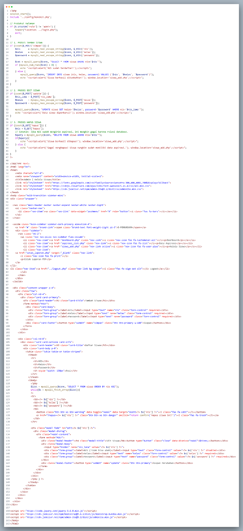
<?php
session_start();
include '../config/koneksi.php';

// Proteksi Halaman
if ($_SESSION['role'] != 'admin') {
header("Location: ../login.php");
exit;
}

// 1. PROSES TAMBAH SISWA
if (isset($_POST['simpan'])) {
$nis = mysqli_real_escape_string($conn, $_POST['nis']);
$kelas = mysqli_real_escape_string($conn, $_POST['kelas']);
$password = mysqli_real_escape_string($conn, $_POST['password']);

$cek = mysqli_query($conn, "SELECT * FROM siswa WHERE nis='$nis'");
if (mysqli_num_rows($cek) > 0) {
echo "<script>alert('NIS sudah terdaftar!');</script>";
} else {
mysqli_query($conn, "INSERT INTO siswa (nis, kelas, password) VALUES ('$nis', '$kelas', '$password')");
echo "<script>alert('Siswa berhasil ditambahkan!'); window.location='siswa_add.php';</script>";
}
}

// 2. PROSES EDIT SISWA
if (isset($_POST['update'])) {
$nis_lama = $_POST['nis_lama'];
$kelas = mysqli_real_escape_string($conn, $_POST['kelas']);
$password = mysqli_real_escape_string($conn, $_POST['password']);

mysqli_query($conn, "UPDATE siswa SET kelas='$kelas', password='$password' WHERE nis='$nis_lama'");
echo "<script>alert('Data siswa diperbarui!'); window.location='siswa_add.php';</script>";
}

// 3. PROSES HAPUS SISWA
if (isset($_GET['hapus'])) {
$nis = $_GET['hapus'];
// Catatan: Jika NIS sudah mengirim aspirasi, ini mungkin gagal karena relasi database.
$query = mysqli_query($conn, "DELETE FROM siswa WHERE nis='$nis'");
if($query){
echo "<script>alert('Siswa berhasil dihapus!'); window.location='siswa_add.php';</script>";
} else {
echo "<script>alert('Gagal menghapus! Siswa mungkin sudah memiliki data aspirasi.'); window.location='siswa_add.php';</script>";
}
}
?>

<!DOCTYPE html>
<html lang="en">
<head>
<meta charset="utf-8">
<meta name="viewport" content="width=device-width, initial-scale=1">
<title>Admin | Kelola Siswa</title>
<link rel="stylesheet" href="https://fonts.googleapis.com/css?family=Source+Sans+Pro:300,400,400i,700&display=fallback">
<link rel="stylesheet" href="https://cdnjs.cloudflare.com/ajax/libs/font-awesome/5.15.4/css/all.min.css">
<link rel="stylesheet" href="https://cdn.jsdelivr.net/npm/admin-lte@3.2/dist/css/adminlte.min.css">
</head>
<body class="hold-transition sidebar-mini">
<div class="wrapper">

<nav class="main-header navbar navbar-expand navbar-white navbar-light">
<ul class="navbar-nav">
<li class="nav-item"><a class="nav-link" data-widget="pushmenu" href="#" role="button"><i class="fas fa-bars"></i></a></li>
</ul>
</nav>

<aside class="main-sidebar sidebar-dark-primary elevation-4">
<a href="#" class="brand-link"><span class="brand-text font-weight-light pl-3">E-PENGADUAN</span></a>
<div class="sidebar">
<nav class="mt-2">
<ul class="nav nav-pills nav-sidebar flex-column">
<li class="nav-item"><a href="dashboard.php" class="nav-link"><i class="nav-icon fas fa-tachometer-alt"></i><p>Dashboard</p></a></li>
<li class="nav-item"><a href="aspirasi_list.php" class="nav-link"><i class="nav-icon fas fa-list"></i><p>Data Aspirasi</p></a></li>
<li class="nav-item"><a href="siswa_add.php" class="nav-link active"><i class="nav-icon fas fa-user-plus"></i><p>Kelola Siswa</p></a></li>
<li class="nav-item">
<a href="cetak_laporan.php" target="_blank" class="nav-link">
<i class="nav-icon fas fa-print"></i>
<p>Cetak Laporan PDF</p>
</a>
</li>
<li class="nav-item"><a href="../logout.php" class="nav-link bg-danger"><i class="fas fa-sign-out-alt"></i> Logout</a></li>
</ul>
</nav>
</div>
</aside>

<div class="content-wrapper p-4">
<div class="row">
<div class="col-md-4">
<div class="card card-primary">
<div class="card-header"><h3 class="card-title">Tambah Siswa</h3></div>
<form method="POST">
<div class="card-body">
<div class="form-group"><label>NIS</label><input type="text" name="nis" class="form-control" required></div>
<div class="form-group"><label>Kelas</label><input type="text" name="kelas" class="form-control" required></div>
<div class="form-group"><label>Password</label><input type="text" name="password" class="form-control" required></div>
</div>
<div class="card-footer"><button type="submit" name="simpan" class="btn btn-primary w-100">Simpan</button></div>
</form>
</div>
</div>

<div class="col-md-8">
<div class="card card-outline card-info">
<div class="card-header"><h3 class="card-title">Daftar Siswa</h3></div>
<div class="card-body p-0">
<table class="table table-sm table-striped">
<thead>
<tr>
<th>NIS</th>
<th>Kelas</th>
<th>Password</th>
<th style="width: 150px">Aksi</th>
</tr>
</thead>
<tbody>
<?php
$list = mysqli_query($conn, "SELECT * FROM siswa ORDER BY nis ASC");
while($s = mysqli_fetch_array($list)){
?>
<tr>
<td><?= $s['nis'] ?></td>
<td><?= $s['kelas'] ?></td>
<td><?= $s['password'] ?></td>
<td>
<button class="btn btn-xs btn-warning" data-toggle="modal" data-target="#edit<?= $s['nis'] ?>"><i class="fas fa-edit"></i></button>
<a href="?hapus=<?= $s['nis'] ?>" class="btn btn-xs btn-danger" onclick="return confirm('Hapus siswa ini?')"><i class="fas fa-trash"></i></a>
</td>
</tr>

<div class="modal fade" id="edit<?= $s['nis'] ?>">
<div class="modal-dialog">
<div class="modal-content">
<form method="POST">
<div class="modal-header"><h4 class="modal-title">Edit Siswa</h4><button type="button" class="close" data-dismiss="modal">&times;</button></div>
<div class="modal-body">
<input type="hidden" name="nis_lama" value="<?= $s['nis'] ?>">
<div class="form-group"><label>NIS (Tidak bisa ubah)</label><input type="text" class="form-control" value="<?= $s['nis'] ?>" disabled></div>
<div class="form-group"><label>Kelas</label><input type="text" name="kelas" class="form-control" value="<?= $s['kelas'] ?>" required></div>
<div class="form-group"><label>Password</label><input type="text" name="password" class="form-control" value="<?= $s['password'] ?>" required></div>
</div>
<div class="modal-footer"><button type="submit" name="update" class="btn btn-primary">Simpan Perubahan</button></div>
</form>
</div>
</div>
</div>
<?php } ?>
</tbody>
</table>
</div>
</div>
</div>
</div>
</div>
</div>

<script src="https://code.jquery.com/jquery-3.6.0.min.js"></script>
<script src="https://cdn.jsdelivr.net/npm/bootstrap@4.6.1/dist/js/bootstrap.bundle.min.js"></script>
<script src="https://cdn.jsdelivr.net/npm/admin-lte@3.2/dist/js/adminlte.min.js"></script>
</body>
</html>
- Langkah 11 – Fitur Cetak Laporan (admin/cetak_laporan.php)
Fitur ini akan membuka tab baru dan memicu perintah print otomatis pada browser. Kita akan menggunakan fungsi window.print() dari JavaScript.
Buka file cetak_laporan.php yang ada pada folder admin, kemudian isi dengan kode berikut :
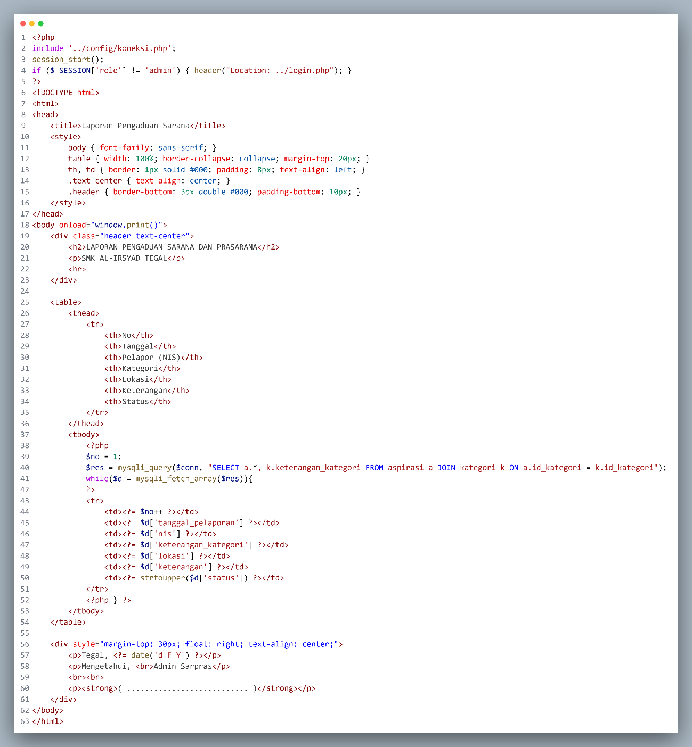
<?php
include '../config/koneksi.php';
session_start();
if ($_SESSION['role'] != 'admin') { header("Location: ../login.php"); }
?>
<!DOCTYPE html>
<html>
<head>
<title>Laporan Pengaduan Sarana</title>
<style>
body { font-family: sans-serif; }
table { width: 100%; border-collapse: collapse; margin-top: 20px; }
th, td { border: 1px solid #000; padding: 8px; text-align: left; }
.text-center { text-align: center; }
.header { border-bottom: 3px double #000; padding-bottom: 10px; }
</style>
</head>
<body onload="window.print()">
<div class="header text-center">
<h2>LAPORAN PENGADUAN SARANA DAN PRASARANA</h2>
<p>SMK AL-IRSYAD TEGAL</p>
<hr>
</div>

<table>
<thead>
<tr>
<th>No</th>
<th>Tanggal</th>
<th>Pelapor (NIS)</th>
<th>Kategori</th>
<th>Lokasi</th>
<th>Keterangan</th>
<th>Status</th>
</tr>
</thead>
<tbody>
<?php
$no = 1;
$res = mysqli_query($conn, "SELECT a.*, k.keterangan_kategori FROM aspirasi a JOIN kategori k ON a.id_kategori = k.id_kategori");
while($d = mysqli_fetch_array($res)){
?>
<tr>
<td><?= $no++ ?></td>
<td><?= $d['tanggal_pelaporan'] ?></td>
<td><?= $d['nis'] ?></td>
<td><?= $d['keterangan_kategori'] ?></td>
<td><?= $d['lokasi'] ?></td>
<td><?= $d['keterangan'] ?></td>
<td><?= strtoupper($d['status']) ?></td>
</tr>
<?php } ?>
</tbody>
</table>

<div style="margin-top: 30px; float: right; text-align: center;">
<p>Tegal, <?= date('d F Y') ?></p>
<p>Mengetahui, <br>Admin Sarpras</p>
<br><br>
<p><strong>( ........................... )</strong></p>
</div>
</body>
</html>

- Langkah 12 – Landing Page (index.php)
Halaman ini sangat penting untuk menunjukkan transparansi sekolah, di mana masyarakat sekolah bisa melihat statistik pengaduan tanpa harus login, namun tetap harus login jika ingin mengirim aspirasi.
Kita akan menggunakan desain Hero Section yang modern dengan integrasi DataTables agar pengunjung bisa mencari data pengaduan yang sudah masuk.
Buka file index.php yang ada pada folder Utama pengaduan_sarana, kemudian isi dengan kode berikut :
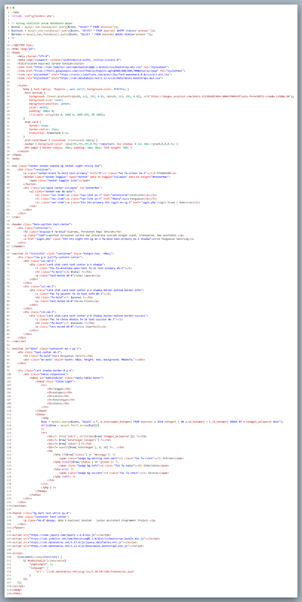
<?php
include 'config/koneksi.php';

// Hitung statistik untuk dashboard depan
$total = mysqli_num_rows(mysqli_query($conn, "SELECT * FROM aspirasi"));
$selesai = mysqli_num_rows(mysqli_query($conn, "SELECT * FROM aspirasi WHERE status='selesai'"));
$proses = mysqli_num_rows(mysqli_query($conn, "SELECT * FROM aspirasi WHERE status='proses'"));
?>

<!DOCTYPE html>
<html lang="en">
<head>
<meta charset="UTF-8">
<meta name="viewport" content="width=device-width, initial-scale=1.0">
<title>Sistem Aspirasi Sarana Sekolah</title>
<link href="https://cdn.jsdelivr.net/npm/bootstrap@5.3.0/dist/css/bootstrap.min.css" rel="stylesheet">
<link href="https://fonts.googleapis.com/css2?family=Poppins:wght@300;400;600;700&display=swap" rel="stylesheet">
<link rel="stylesheet" href="https://cdnjs.cloudflare.com/ajax/libs/font-awesome/6.0.0/css/all.min.css">
<link rel="stylesheet" href="https://cdn.datatables.net/1.13.4/css/dataTables.bootstrap5.min.css">

<style>
body { font-family: 'Poppins', sans-serif; background-color: #f8f9fa; }
.hero-section {
background: linear-gradient(rgba(0, 123, 255, 0.8), rgba(0, 123, 255, 0.8)), url('https://images.unsplash.com/photo-1523050853064-80041f00965f?auto=format&fit=crop&w=1350&q=80');
background-size: cover;
background-position: center;
color: white;
padding: 100px 0;
clip-path: polygon(0 0, 100% 0, 100% 85%, 0% 100%);
}
.stat-card {
border: none;
border-radius: 15px;
transition: transform 0.3s;
}
.stat-card:hover { transform: translateY(-10px); }
.navbar { background-color: rgba(255,255,255,0.95) !important; box-shadow: 0 2px 10px rgba(0,0,0,0.1); }
.btn-login { border-radius: 30px; padding: 10px 30px; font-weight: 600; }
</style>
</head>
<body>

<nav class="navbar navbar-expand-lg navbar-light sticky-top">
<div class="container">
<a class="navbar-brand fw-bold text-primary" href="#"><i class="fas fa-school me-2"></i>E-PENGADUAN</a>
<button class="navbar-toggler" type="button" data-bs-toggle="collapse" data-bs-target="#navbarNav">
<span class="navbar-toggler-icon"></span>
</button>
<div class="collapse navbar-collapse" id="navbarNav">
<ul class="navbar-nav ms-auto">
<li class="nav-item"><a class="nav-link px-3" href="#statistik">Statistik</a></li>
<li class="nav-item"><a class="nav-link px-3" href="#data">Data Pengaduan</a></li>
<li class="nav-item"><a class="btn btn-primary btn-login ms-lg-3" href="login.php">Login Siswa / Admin</a></li>
</ul>
</div>
</div>
</nav>

<header class="hero-section text-center">
<div class="container">
<h1 class="display-4 fw-bold">Suaramu, Perubahan Bagi Sekolah</h1>
<p class="lead">Laporkan kerusakan sarana dan prasarana sekolah dengan cepat, transparan, dan akuntabel.</p>
<a href="login.php" class="btn btn-light btn-lg mt-3 fw-bold text-primary px-5 shadow">Kirim Pengaduan Sekarang</a>
</div>
</header>

<section id="statistik" class="container" style="margin-top: -50px;">
<div class="row g-4 justify-content-center">
<div class="col-md-3">
<div class="card stat-card text-center p-4 shadow">
<i class="fas fa-envelope-open-text fa-3x text-primary mb-3"></i>
<h2 class="fw-bold"><?= $total ?></h2>
<p class="text-muted mb-0">Total Laporan</p>
</div>
</div>
<div class="col-md-3">
<div class="card stat-card text-center p-4 shadow border-bottom border-info">
<i class="fas fa-spinner fa-3x text-info mb-3"></i>
<h2 class="fw-bold"><?= $proses ?></h2>
<p class="text-muted mb-0">Dalam Proses</p>
</div>
</div>
<div class="col-md-3">
<div class="card stat-card text-center p-4 shadow border-bottom border-success">
<i class="fas fa-check-double fa-3x text-success mb-3"></i>
<h2 class="fw-bold"><?= $selesai ?></h2>
<p class="text-muted mb-0">Tuntas Diperbaiki</p>
</div>
</div>
</div>
</section>

<section id="data" class="container my-5 py-5">
<div class="text-center mb-5">
<h2 class="fw-bold">Data Pengaduan Terkini</h2>
<div class="mx-auto" style="width: 60px; height: 4px; background: #0d6efd;"></div>
</div>

<div class="card shadow border-0 p-4">
<div class="table-responsive">
<table id="tabelPublik" class="table table-hover">
<thead class="table-light">
<tr>
<th>Tanggal</th>
<th>Kategori</th>
<th>Lokasi</th>
<th>Keterangan</th>
<th>Status</th>
</tr>
</thead>
<tbody>
<?php
$sql = mysqli_query($conn, "SELECT a.*, k.keterangan_kategori FROM aspirasi a JOIN kategori k ON a.id_kategori = k.id_kategori ORDER BY a.tanggal_pelaporan DESC");
while($row = mysqli_fetch_array($sql)){
?>
<tr>
<td><?= date('d/m/Y', strtotime($row['tanggal_pelaporan'])) ?></td>
<td><?= $row['keterangan_kategori'] ?></td>
<td><?= $row['lokasi'] ?></td>
<td><?= substr($row['keterangan'], 0, 50) ?>...</td>
<td>
<?php if($row['status'] == 'menunggu'): ?>
<span class="badge bg-warning text-dark"><i class="fas fa-clock"></i> Antrean</span>
<?php elseif($row['status'] == 'proses'): ?>
<span class="badge bg-info"><i class="fas fa-tools"></i> Dikerjakan</span>
<?php else: ?>
<span class="badge bg-success"><i class="fas fa-check"></i> Selesai</span>
<?php endif; ?>
</td>
</tr>
<?php } ?>
</tbody>
</table>
</div>
</div>
</section>

<footer class="bg-dark text-white py-4">
<div class="container text-center">
<p class="mb-0">&copy; 2026 E-Pengaduan Sekolah - SMK AL-IRSYAD TEGAL</p>
</div>
</footer>

<script src="https://code.jquery.com/jquery-3.6.0.min.js"></script>
<script src="https://cdn.jsdelivr.net/npm/bootstrap@5.3.0/dist/js/bootstrap.bundle.min.js"></script>
<script src="https://cdn.datatables.net/1.13.4/js/jquery.dataTables.min.js"></script>
<script src="https://cdn.datatables.net/1.13.4/js/dataTables.bootstrap5.min.js"></script>

<script>
$(document).ready(function() {
$('#tabelPublik').DataTable({
"pageLength": 5,
"language": {
"url": "//cdn.datatables.net/plug-ins/1.10.24/i18n/Indonesian.json"
}
});
});
</script>
</body>
</html>

- Langkah 13 – Menjalankan Project
- Pastikan apache dan MySQL pada XAMPP sudah berjalan / start dan muncul angka pada port
- Buka browser (chrome atau mozilla)
- Ketikkan pada address bar localhost/pengaduan_sarana
Jika tidak ada kesalahan, maka akan muncul tampilan landing page sebagai berikut :
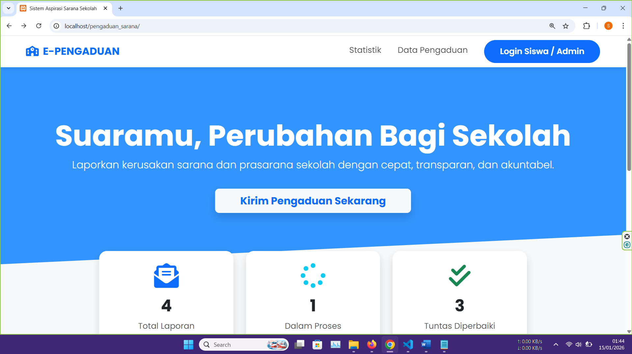

- Langkah 14 – Login Sebagai Siswa
Masuk ke halaman login dan masukan
NIS = 12345
Password = siswa123

- Langkah 15 – Login Sebagai Admin
Masuk ke halaman login dan masukan
username = admin
Password = admin123

- Langkah 16 – Lakukan Pengujian
Lakukan pengujian total pada aplikasi untuk memastikan tidak ada bug, kesalahan ataupun error.
Pastikan semua fitur telah berjalan dengan baik.
Pastikan semua halaman tampil dengan sempurna.
Tambahkan fitur lain jika perlu seperti buat akun baru untuk siswa.

SELESAI – HAPPY CODING

